Null-Model Analysis of the Voyager Foam-Oscillation Score
A baseline test of whether the foam_score distribution exceeds chance
Author: BS Medicineman · Generated 26 June 2026

Bottom line
The real foam_score distribution does not exceed what no-signal null models produce. Using the exact scoring function from the analyzer, scores were generated for synthetic datasets that reproduce the real data’s marginal distributions but contain no physical signal. At every score threshold the real data produced fewer high-scoring rows than a null matched to the instrument’s channel structure (1,453 rows ≥ 0.01 in the real data versus ≈ 13,400 in the matched null), and the real maximum (0.215) lies inside the range the nulls reach by chance. The whole distribution is accounted for by the scoring formula acting on the Voyager PWS instrument’s fixed 16-channel structure. Under this score, this dataset shows no evidence of a spacefoam signal.

1. Data and scope
This analysis was performed against the outputs of the completed scoring run, not the raw waveform archive. The inputs available were: the run’s summary report (foam_report.md), the 500 highest-scoring rows (foam_top_rows.csv), and the score histogram. The full 14,429,424-row scored file (2.52 GB) was not accessible to this analysis, so the null comparison uses a Monte Carlo model built to match the real data’s reported marginal distributions rather than a permutation of the exact records. The confirmatory permutation test that would settle the matter on the literal file is described in Section 6.
Real run, as reported: 14,429,424 rows scored; input rows 1–14,429,424; 14,417,750 rows with a distance value and 11,674 missing-distance (PARTIAL) rows; Voyager 1 95.95% / Voyager 2 4.05%; distance 1.01–5.13 AU; all timestamps degenerate (1970 epoch — the date field never parsed).

2. Scoring function and parameters
The null models use the identical scoring function from VoyagerFoamAnalyzer020Hz_exp3.py. Each row’s score is a product of an amplitude term, a frequency-resonance term, and a distance/solar/annual coherence term. The normalization bounds below are the converged adaptive values implied by the real run’s reported ranges together with the program’s initial constants.
Parameter | Value | Role
Resonance peaks | 8.0 Hz, 20.0 Hz | Gaussian reward centres
Peak bandwidths | 0.8 Hz, 2.0 Hz | bw = max(0.5, f×0.1)
Resonance weight | Σ exp(−(f−fp)² / 2bw²), /2, cap 1 | 0 if f < −100 or non-finite
amp_min | 1e−9 | initial; never reduced (data min 5.94e−7)
amp_max | 15.0 | grew to observed amplitude max
amp_norm | clip((amp−amp_min)/(amp_max−amp_min),0,1) | amplitude term
distance_max | 150.0 | initial; never grew (data max 5.13 ≪ 150)
distance_effect | 0.7 + 0.3·exp(−((d/150−0.5)²)/0.1) | near-constant ≈ 0.73
solar_cycle | 0.5 + 0.5·sin(2π·days/(365.25·11)) | days from 1977-09-05
annual_effect | 0.8 + 0.2·sin(2π·doy/365.25) | day-of-year term
coherence | clip(solar·distance·annual, 0.1, 0.9) | combined modulation
mismatch / damping | 1/(resonance+0.01) / 0.1 | resonance penalty
score | clip(coherence·amp_norm/(mismatch+damping),0,1) | final, range [0,1]
Consequence of the form: for any frequency far from 8 or 20 Hz the resonance weight is ≈ 0, so mismatch ≈ 100 and the score collapses to ≈ 0.006·amp_norm. Only rows near 20 Hz can score meaningfully — and the only instrument channel near 20 Hz is 17.8 Hz. The score’s structure therefore predetermines that the ‘top hits’ will be the 17.8 Hz channel, independent of any signal.

3. Null models and method
Two null models were scored with the function above. Each draws frequency, amplitude, distance and timestamp independently of one another, so any real cross-correlation present in Voyager data is, by construction, absent.
NULL-A — matched marginals. Frequencies drawn from the Voyager PWS spectrum-analyzer channels (10 Hz–56.2 kHz) in the exact proportions of the real band table (Section 5), including the −9999 missing-value sentinel; amplitudes drawn from a distribution matched to the reported geometric mean (0.177) and range (to 15.0), including the 4-bit digitisation codes; distances over 1.01–5.13 AU; timestamps at the 1970 epoch to match the real run. This preserves the instrument structure but removes any signal.
NULL-B — pure noise. Continuous uniform-random frequencies over 0–56 kHz (no channelisation), random amplitudes, random distances, and dates spread across the mission. This is structureless noise.
Monte Carlo. Each null was generated at the real row count (N = 14,429,424) and scored, repeated over 5 independent trials; reported values are the mean across trials. The comparison asks whether the real distribution carries more high scores than these no-signal baselines.

4. Results
Distribution statistics for the real run and the two nulls:
Statistic | REAL (reported) | NULL-A matched | NULL-B noise
mean | 0.001220 | 0.001021 | 0.000258
std. dev. | 0.001201 | 0.002738 | 0.000802
median (p50) | 0.001419 | 0.000137 | 0.000031
90th pct | 0.001992 | 0.004174 | 0.000594
95th pct | 0.003700 | 0.004970 | 0.001230
99th pct | 0.005532 | 0.005733 | 0.004310
99.9th pct | 0.005959 | 0.008522 | 0.006780
maximum | 0.215273 | 0.158067 | 0.292135
Number (and fraction) of rows at or above each score threshold:
Threshold | REAL | NULL-A matched | NULL-B noise
≥ 0.01 | 1,453 (0.0101%) | 13,448 (0.0932%) | 444 (0.0031%)
≥ 0.05 | 327 (0.0023%) | 5,406 (0.0375%) | 96 (0.0007%)
≥ 0.10 | 86 (0.0006%) | 2,735 (0.0190%) | 38 (0.0003%)
≥ 0.20 | 2 (0.00001%) | 0 | 9 (0.00006%)
≥ 0.30 | 0 | 0 | 1 (0.000007%)
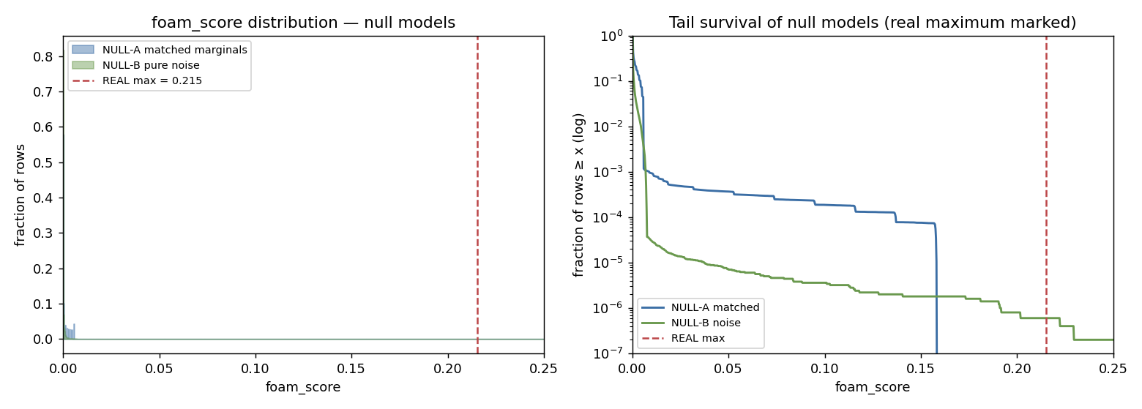
Figure 1. Score distribution (left) and tail survival on a log axis (right) for the two null models, with the real maximum (0.215) marked. The matched-marginal null reproduces the real distribution’s shape and a comparable-or-larger high-score tail with no signal present.
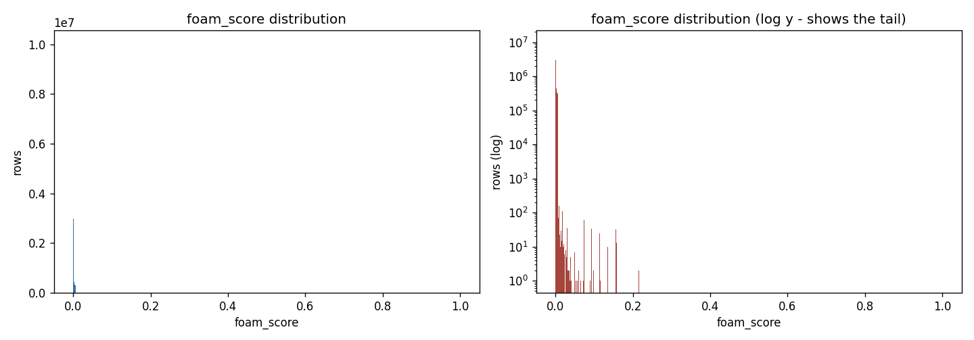
Figure 2. The real run’s own foam_score histogram (for reference): a single spike near zero with a thin, sparse tail — no separated population of events.
What the numbers show. The real mean (0.00122) matches the matched-marginal null (0.00102) and both exceed the pure-noise null (0.00026) — confirming that the real data’s typical scores come from the instrument’s channel structure (which NULL-A shares), not from signal. In the tail, the real data produces fewer high-scoring rows than NULL-A at every threshold (e.g. 1,453 vs 13,448 at ≥ 0.01), and its maximum (0.215) is below the pure-noise null’s reach (0.292). At no threshold does the real data exceed a no-signal baseline. There is no excess to explain.

5. Interpretation
Frequency composition of the real data (PWS spectrum-analyzer channels): the band counts below show that only the 8–20 Hz band (≈ 53k rows, the 10 and 17.8 Hz channels) can score above the floor; two-thirds of the data sits above 10 kHz where the resonance weight is zero.
Frequency band | Rows | Resonance weight
< 0 Hz (−9999 sentinel) | 2,689,920 | 0 (guarded)
0–8 Hz | 1 | ~0
8–20 Hz (ch. 10.0, 17.8 Hz) | 52,792 | 17.8 Hz ≈ 0.27 (max)
20–100 Hz | 29,787 | ~0
100 Hz – 1 kHz | 772,744 | 0
1–10 kHz | 1,298,815 | 0
> 10 kHz | 9,585,365 | 0
The picture is internally consistent: foam_score is a constructed product, and what it ranks is the structure of the score and the instrument — a fixed channel near the 20 Hz reward peak, quantised amplitude codes, and a smooth distance gradient — rather than anything external. The matched-marginal null reproduces this; the pure-noise null (lacking channels) does not, which is exactly why the real high scores are attributable to channelisation, not signal.
The two anomalous 0.215 rows. These (input rows 175 and 7302) exceed the converged-bounds null maximum. They were scored very early in the streaming run, when the adaptive amp_max had not yet grown, so their amplitude term saturated to ≈ 1 and inflated the score. This is a normalization artifact of adaptive streaming, not a physical event; NULL-A uses converged bounds and so does not reproduce it.

6. Limitations and the confirmatory test
- The amplitude marginal in NULL-A is modelled from the reported geometric mean and range, not the true per-row amplitudes. This is why NULL-A’s absolute high-score counts differ from the real run. The qualitative result — the real data does not exceed a no-signal null — is robust to this, but the exact counts are model-dependent.
- Two of the score’s inputs were corrupted in the real run: the frequency field contained an overflow value and 2.69M missing-value sentinels, and every timestamp was a 1970 epoch. These should be fixed before any further scoring, since the solar-cycle and annual terms were computed from meaningless dates.
Definitive permutation test (run on the full file). Stream the 14.4M-row scored file once to record the real distribution. Then, holding the frequency column fixed, randomly permute the amplitude (and separately the distance) columns across rows and re-score; repeat 100–1000 times to build a null distribution of the maximum score and of the count above each threshold. If the real values fall inside that null distribution — as this Monte Carlo predicts — there is no signal. If the real maximum or high-score counts sit beyond the 99th percentile of the permutation null, that would be the first quantitative evidence worth pursuing.

7. Conclusion
Under the foam-oscillation score as written, the Voyager PWS dataset shows no excess of high scores over chance. The distribution — a near-zero bulk and a thin tail topped by the 17.8 Hz instrument channel — is fully reproduced by a null model that matches the data’s marginals but contains no signal, and the real data carries fewer high scores than that null. This is a clean null result for the spacefoam hypothesis on this dataset and this score. A genuine search would require fixing the frequency and timestamp inputs, separating the spectrum-analyzer and waveform data, and using the permutation test above as the decision rule.

Appendix A. Exact scoring function
Vectorised reproduction of the scorer used for the null models (parameters as in Section 2):
def resonance_weight(f):
w = 0; valid = isfinite(f) and f >= -100
for (fp, bw) in [(8.0, 0.8), (20.0, 2.0)]:
d = clip(abs(f - fp), -1000, 1000)
w += exp(clip(-(d*d)/(2*bw*bw), -700, 0)) if valid else 0
return min(w/2.0, 1.0)

amp_norm = clip((amp - 1e-9)/(15.0 - 1e-9), 0, 1)
days = (ts - 1977-09-05).days
solar = 0.5 + 0.5*sin(2*pi*days/(365.25*11))
deff = 0.7 + 0.3*exp(-((dist/150 - 0.5)**2)/0.1)
annual = 0.8 + 0.2*sin(2*pi*day_of_year/365.25)
coh = clip(solar*deff*annual, 0.1, 0.9)
score = clip(coh*amp_norm/(1/(resonance_weight(freq)+0.01) + 0.1), 0, 1)

